**Migrate SQL Server to Azure SQL Database using DMS project solution**

|  |  |
| --- | --- |
| **Activity #** | **Steps** |
| **Activity 1:**  Navigate to azure portal | Step 1: Sign in to the Azure Portal and Create a target instance of Azure SQL Database  Step 2: On On-prem server, Download and install Azure Data Studio.  Install the Azure SQL Migration extension from Azure Data Studio Marketplace. |
| **Activity 2:**  Signing in. | Ensure to have following built-in roles:   * Contributor for the target instance of Azure SQL Database * Reader role for the Azure resource group that contains the target instance of Azure SQL Database * Owner or Contributor role for the Azure subscription |
| **Activity 3:**  Assessing your on-premises database | In Azure Data Studio, go to **Connections**. Select and connect to your on-premises instance of SQL Server > Right-click the server connection and select **Manage > In the server menu under General, select Azure SQL Migration >** In the Azure SQL Migration dashboard, select**Migrate to Azure SQL**to open the migration wizard > In **Step 1: Databases for assessment** in the Migrate to Azure SQL wizard, select the databases you want to assess. Then, select **Next**  **Step 2: Assessment results and recommendations**, complete the following steps:  In **Choose your Azure SQL target**, select **Azure SQL Database**.  We can Review Azure SQL Database Recommendations then Select **Next** to continue your database migration in the wizard. |
| **Activity 4:**  Migrating the sample schema | 1. Run the Data Migration Assistant tool, select the **New (+)** icon, and choose a new Migration option under the Project type. 2. Select the SQL Server as the source server and Azure Server as the destination server. 3. Select the **Schema only** option under the **Migration scope**. 4. Finally, go to **Create** option to create a project. Here, connect to your SQL server and select the database. 5. Select the Azure Server for the destination server and connect it. 6. Choose the schema objects from your database 7. To create the SQL scripts, select Generate SQL scripts option 8. At last, deploy the schema to the Azure SQL database. |
| **Activity 5:**  Registering the resource provider | Make sure that the Microsoft.DataMigration resource provider is registered in your subscription.  Azure portal > subscriptions > Resource providers > To register a resource provider, select the resource provider and then select **Register** |
| **Activity 6:** Creating an Azure Database Migration Service instance | In the Azure portal, navigate to the Azure Database Migration Service page. Create a new instance of Azure Database Migration Service  Select the desired input like Source and Target server type, choose **Database Migration Service** and choose **Select**  **Create Data Migration Service**, select your subscription and resource group, then select **Location**, and enter the Database Migration Service name. Select **Review + Create** |
| **Activity 7:**  Creating a migration project | In **Step 2** to start a new migration using Database Migration Service from Azure portal, under **Azure Database Migration Services**, select an existing instance of Database Migration Service that you want to use, and then select **New Migration**  Under **Select new migration** scenario, choose your source > SQL server, target server type > Azure sql database, migration mode> Database migration service and choose **Select**. |
| **Activity 8:**  Specifying source details | Provide below details to **connect to source SQL server** and select Next:   * Source server name * Authentication type * User name and password * Connection properties |
| **Activity 9:**  Selecting databases for migration | On next page, **select databases for migration**. |
| **Activity 10:**  Specifying target details | provide the target details on **Connect to target Azure SQL Database** page, and select Next:   * Azure subscription * Azure resource group * Target Azure SQL Database server * Authentication type * User name and password   Under **Map source and target databases**, map the databases between source and target.  Then, **Select database tables to migrate** for each selected database and select the tables  For the type of activity, select **Offline Data Migration**  Review all the inputs provided on **Database migration summary** page and select **Start migration** button to start the database migration. |

**Monitor the database migration**

1. In the Database Migration Service instance overview, select Monitor migrations to view the details of database migrations.

Under the **Migrations** tab, select **Refresh** to update the migration status

*screenshot after successfully creating an Azure Database Migration Service instance.*

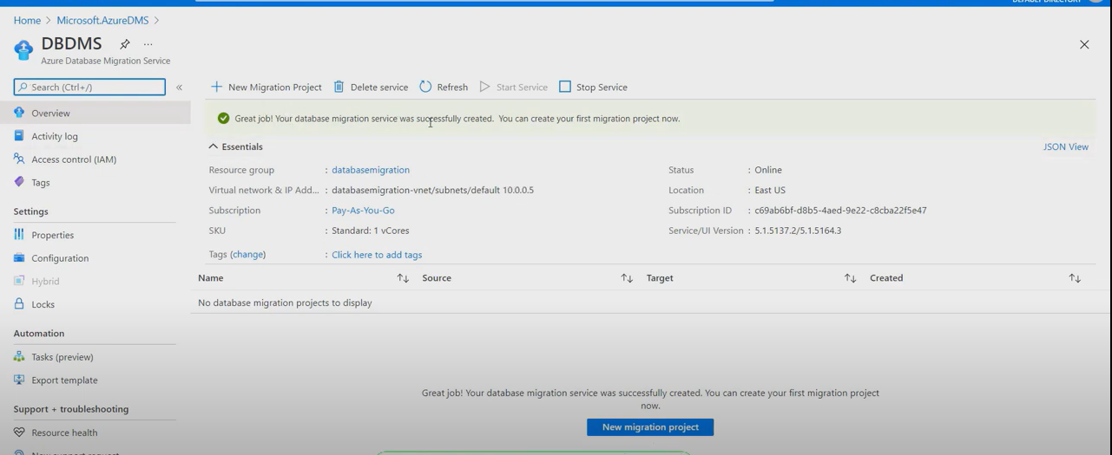

*Screenshot after successfully migrating the schema.*

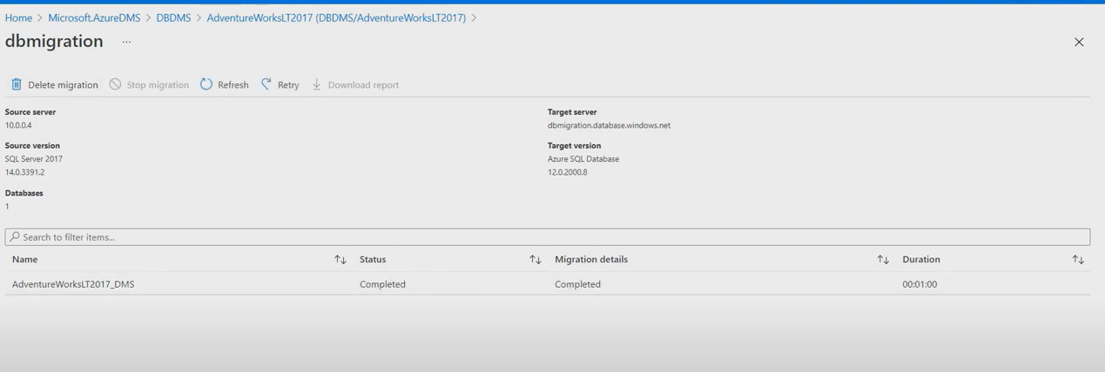

*screenshot after running the migration.*

